This summer, Arbor Park Middle School is collaborating with Acorn Public Library for the Summer Reading Program, “Reading is Groovy.”
Upcoming sixth grade students are encouraged to:
- Register for the Young Adult Summer Reading Program 2018 at Acorn Public Library starting June 2, 2018.
15624 Central Avenue
Oak Forest, IL 60452
708.687.3700

- Complete reading logs provided by Acorn Library.

- Each time you read for ten days (they do not need to be consecutive), check in with the library for raffle prizes.

- The deadline for all reading logs is July 28, 2018.

- In addition to prizes from the library, all students who complete the challenge will be invited to the Back to School Summer Reading Challenge Bash at Arbor Park when we return from break.

- Please see the attached brochure for more information. Acorn Library will provide Ms. Fox, Ms. Harker, and Ms. Koschnitzki with names of all participants.

Acorn Library Reading Kick Off Party

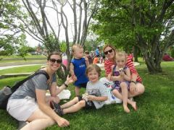

When:
Saturday, June 2, at 11:00 A.M.

Where:
South Lawn of Acorn Public Library

Ages:
All

About:
Register for the reading program at our outdoor bash! There will be a petting zoo, bounce house, dunk tank, ice cream, a magician creating balloon animals, a DJ, face painting, and more! Reading programs with amazing prizes are available for kids and teens.

To Register:
- No registration required.

